Pneumatic Task Report | By Joseph Ashton, 27047440  For Industrial Automation, EGR3039

Components | 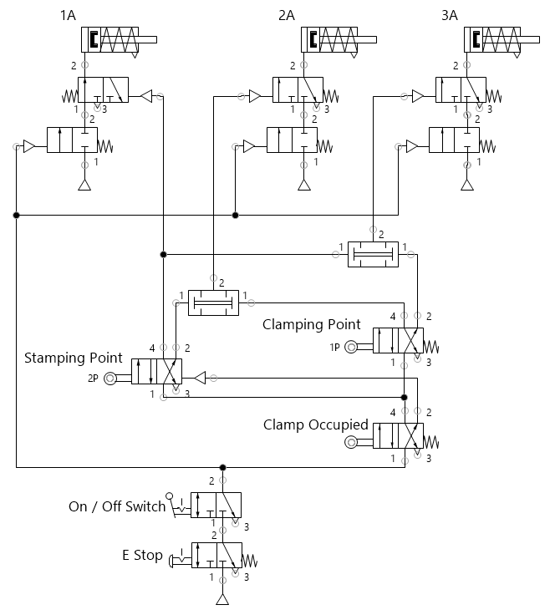Figure 1: Stamping Machine, FluidSIM Diagram
  Stamping Machine | This section describes a method for automating the stamping machine detailed in Appendix 1 of the Brief
  - Single acting cylinder *3  - 3/2 Way Valve *3  - Pneumatically Actuated  - Spring Return  - 2/2 Way Valve *3  - Pneumatically Actuated  - Spring Return  - Normally Closed  - Twin Pressure Valve *2 | - 4/2 Way Valve *2  - Roller Plunger actuated  - Spring Return  - 4/2 Way Valve *1  - Roller Plunger actuated  - Pneumatically Actuated  - 3/2 Way Valve *1  - Detent Switch  - 3/2 Way Valve *1  - Detent Button  - Spring Return

Metal Casing | This section describes a modular automated process for constructing a metal casing (inspired by my Steinberg UR22C) from a roll of sheet metal.

Cutting Sections
A sheet is fed by conveyor of driven rollers, these have enough friction to pull the sheet forward when it is free but not to crumple/tear it.  When the sheet roll reaches the roller switch, the shear is actuated. This cuts a section of sheet allowing the cut section to advance while blocking the progress of the roll. | 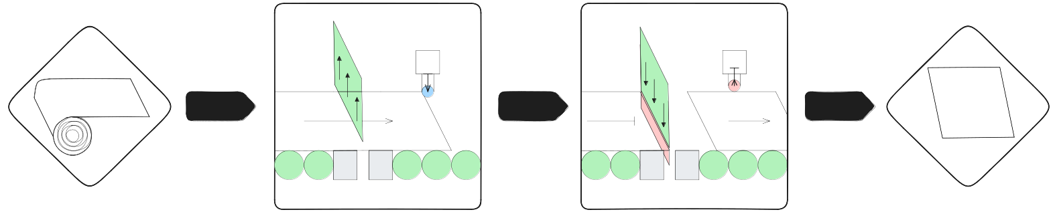Figure 2: Cut Sections, Flow Diagram
Once the sheet section is clear from the switch the shear retracts, this allows the sheet roll to advance again and the cycle repeats. The cut sections can be deposited into a magazine, this gives the production line some buffer between modules.
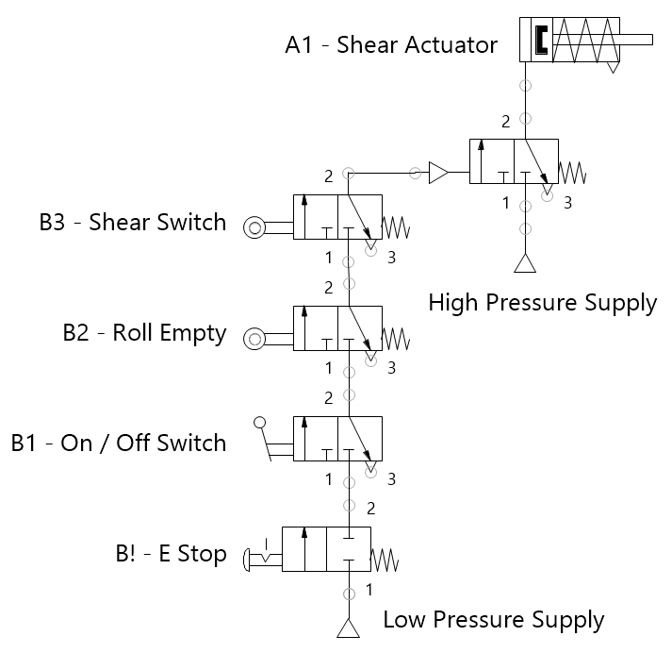Figure 3: Cut Sections, FluidSIM Diagram | Components  - Single Acting Cylinder  - 3/2 Way Valve  - Pneumatic  - Spring Return  - 3/2 Way Valve  - Roller Switch  - Spring return  - 3/2 Way Valve  - Detent Switch  - Spring return  - 2/2 Way Valve  - Detent Button  - Spring Return  - Normally Closed

Magazine Dispense  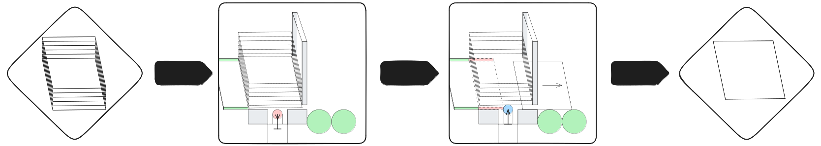Figure 4: Mag Dispense, Flow Diagram  The magazines store a stack of sheet sections, when triggered by a pneumatic signal the bottom most part is dispensed. | Components  - Single Acting Cylinder  - 3/2 Way Valve  - Pneumatic  - Spring Return  - 3/2 Way Valve  - Detent Switch  - Spring return  - 3/2 Way Valve  - Detent Button  - Spring Return | 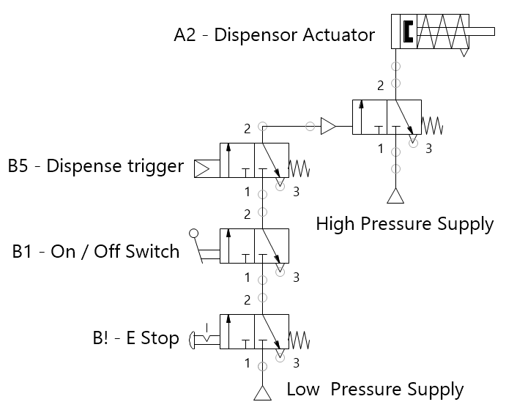Figure 5: Mag Dispense, FluidSIM Diagram

Fold Section
When B6 detects the clamp is empty the magazine dispense is triggered advancing a sheet section. | 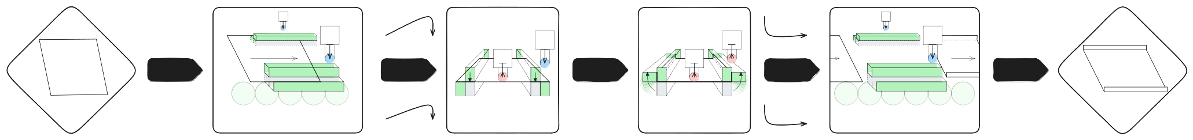Figure 6: Mag Dispense, Flow Diagram
When this reaches B6 the clamp is engaged, and after a brief delay so is the folding mechanism.  When the folding mechanism reaches B7 the folding mechanism is disengaged followed more slowly by the clamp. This allows the folded section to advance out of the clamp into a magazine of the same principle discussed in the previous section. | A similar mechanism following the same principle is used to achieve the second fold.  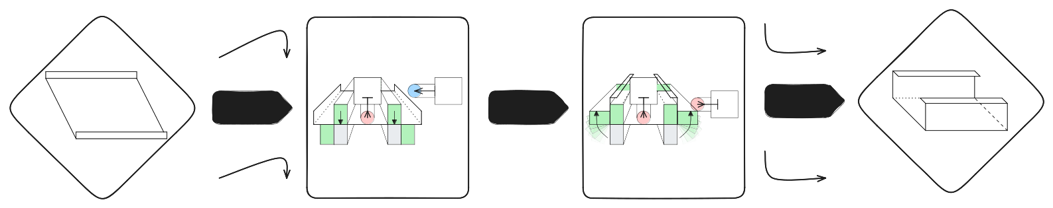Figure 7: Fold 2, Flow Diagram
Components  - Single Acting Cylinder  - One Way Flow Control Valve  - 3/2 Way Valve  - Pneumatic  - Spring Return  - 3/2 Way Valve  - Pneumatic with Pneumatic Timer (normally open)  - Spring Return  - Twin Pressure Valve  - 4/2 Way Valve  - Roller Switch  - Spring return  - 3/2 Way Valve  - Probe Switch  - Spring return  - 3/2 Way Valve  - Detent Switch  - Spring return  - 2/2 Way Valve  - Detent Button  - Spring Return  - Normally Closed | 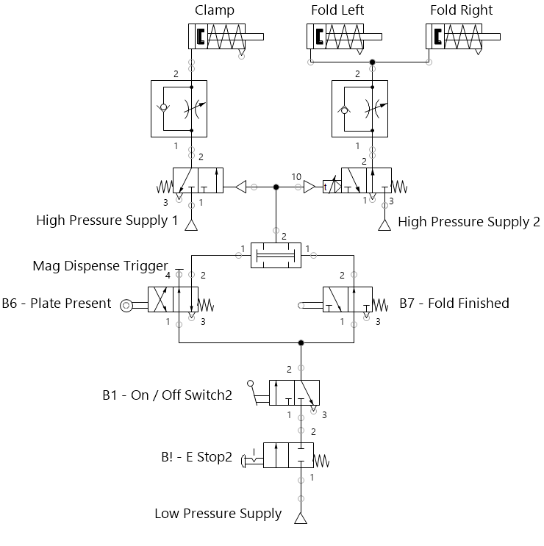Figure 8: Fold Section, FluidSIM Diagram

